Shenzhen TIBTRONIX TECHNOLOGY CO., LTD.
TPPMFH05D4
400Gb/s QSFP-DD DR4 500m Transceiver Hot Pluggable, MPT/MPO-12 Connector, Single Mode 4x100Gb/s EML 1310nm transmitter
2022/9/6

Shenzhen Tibtronix Technology Co., Ltd. 3/F,12th Building, Nangang 1st Industrial Park, Baimang Xili, Songbai Road, Nanshan District, Shenzhen, China Tel: +86 755 23316583 Fax: +86 755 29610056 E-mail: sales@tibtronix.com http://www.tibtronix.com

Features:
- 4 parallel EML 1310nm design
- MPT/MPO-12 connector
- Compliant to QSFP-DD MSA
- IEEE 802.3cd 400GBASE-DR4 Specification compliant
- Compliant with CMIS 4.0 Management interface specifications
- 4x106.25Gb/s electrical interface (400GAUI-8)
- Up to 500m transmission on single mode fiber (SMF) with FEC
- Maximum power consumption 10W
- Single +3.3V power supply operating
- Temperature range 0°C to 70°C
- RoHS Compliant Part

Applications:
- Networks
- Data center and Cloud
Description:
The TPPMFH05D4 is a 400Gb/s QSFP-DD DR4 optical module designed for 500m optical communication applications. The module converts 8 channels of 50Gb/s (PAM4) electrical input data to 4 channels of parallel optical signals, each capable of 100Gb/s operation for an aggregate data rate of 400Gb/s.
On the receiver side, the module converts 4 channels of parallel optical signals of 100Gb/s each channel for an aggregate data rate of 400Gb/s into 8 channels of 50Gb/s (PAM4) electrical output data.
An optical fiber cable with an MTP/MPO-12 connector can be plugged into the QSFP-DD DR4 module receptacle. Host FEC is required to support up to 500m fiber transmission.

  - Absolute Maximum Ratings
Parameter | Symbol | Min. | Typical | Max. | Unit
Storage Temperature | T_{S} | -40 |  | +85 | °C
Supply Voltage | V_{CC}T, R | -0.5 |  | 4 | V
Relative Humidity | RH | 10 |  | 95 | %
  - Recommended Operating Environment:
Parameter | Symbol | Min. | Typical | Max. | Unit
Case operating Temperature | T_{C} | 0 |  | +70 | °C
Supply Voltage | V_{CCT, R} | +3.13 | 3.3 | +3.47 | V
Supply Current | I_{CC} |  |  | 3000 | mA
Power Dissipation | PD |  |  | 10 | W
Pre-FEC Bit Error Ratio |  |  |  | 2.4x10⁻⁴
Link Distance over SMF |  |  |  | 500 | m
  - Electrical Characteristics (T_{OP} = 0 to 70 °C, VCC = 3.13 to 3.47 Volts
Parameter | Symbol | Min | Typ | Max | Unit | Note
Data Rate per Channel |  | - | 26.5625 |  | Gbps
Differential termination mismatch |  |  |  | 10 | %
Transmitter
Single Ended Output Voltage Tolerance |  | 0.3 |  | 4 | V
Transmit Input Diff Voltage | VI | 900 |  |  | mV
Common-mode to Differential Return Loss min |  | 802.3ck 120G
Receiver
Single Ended Output Voltage Tolerance |  | 0.3 |  | 4 | V
Rx Output Diff Voltage | Vo |  |  | 900 | mV
Near-end ESMW(Eye symmetry mask width) |  |  | TBD |  | UI
Near-end Eyeheight, Differential |  | 24 |  |  | mV
Near-end Vertical Eye Closure |  |  |  | 7.5 | dB
Far-end ESMW (Eye Symmetry Mask Widt |  |  | TBD
Far-end Eyeheight, Differentia |  | 24 |  |  | mV
Far-end Vertical Eye Closur |  |  |  | 7.5 | dB
Far-end pre-cursor ISI ratio |  | TBD |  |  | UI
Common Mode to Differential Conversion Return Loss |  | 802.3ck 120G |  |  | dB
Rx Output Rise and Fall Voltage | Tr/Tf |  | TBD |  | ps | 1

Note: 1. 20～80%

  - Optical Parameters(TOP = 0 to 70 °C, VCC = 3.0 to 3.6 Volts)
Parameter | Symbol | Min | Typ | Max | Unit | Ref.
Transmitter
Modulation Format | PAM4
Data Rate per Channel |  | - | 53.125 |  | Gbps
Lane Wavelength Range |  | 1304.5 | 1310 | 1317.5 | nm
Average Optical Power each lane | Po | -2.9 |  | 4 | dBm
RMS Spectral Width |  |  |  | 0.6 | nm
Optical Modulation Amplitude (OMA), each lane |  | -0.8 |  | 4.2 | dBm
Launch Power in OMAouter minus TDECQ, each Lane |  | -2.2 |  | 3.5 | dBm
Extinction Ratio | ER | 3.5 |  |  | dB
Transmitter Transition Time, Each Lane |  |  |  | 17 | ps
Average Launch Power OFF Transmitter, each Lane | Poff |  |  | -30 | dBm
Relative Intensity Noise | Rin |  |  | -136 | dB/HZ | 1
Optical Return Loss Tolerance |  | - | - | 21 | dB
Transmitter Reflectance |  |  |  | -26 | dBm
Receiver
Modulation Format | PAM4
Data Rate per Channel |  | - | 53.125 |  | Gbps
Lane Wavelength Range |  | 1304.5 | 1310 | 1317.5 | nm
Damage Threshold | THd | 5 |  |  | dBm | 1
Average Receive Power, each Lane | R | -5.9 |  | 4 | dBm
Receiver Power (OMA), each Lane | RxOMA | - | - | 4.2 | dBm
Stressed eye closure for PAM4 (SECQ), lane under test |  |  | 4.5 |  | dB
Stressed Receiver Sensitivity (OMA) per Lane | SRS |  |  | -1.9 | dBm
RSSI Accuracy |  | -2.5 |  | 2.5 | dB
Receiver Reflectance | Rrx |  |  | -26 | dB
LOS De-Assert | LOS_{D} |  |  | -10 | dBm
LOS Assert | LOS_{A} | -20 |  |  | dBm
LOS Hysteresis | LOS_{H} | 1.5 |  |  | dB

Note: 1. 12dB Reflection

  - Pin Assignment
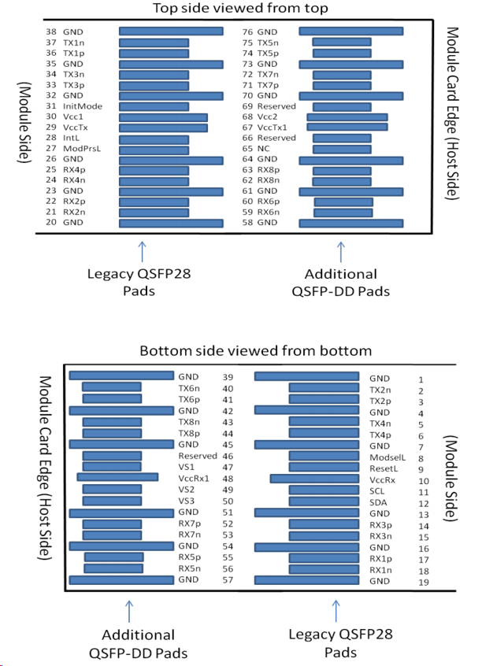
Diagram of Host Board Connector Block Pin Numbers and Name

  - Pin Description
Pin | Logic | Symbol | Name/Description | Ref.
1 |  | GND | Ground | 1
2 | CML-I | Tx2n | Transmitter Inverted Data Input
3 | CML-I | Tx2p | Transmitter Non-Inverted Data Input
4 |  | GND | Ground | 1
5 | CML-I | Tx4n | Transmitter Inverted Data Input
6 | CML-I | Tx4p | Transmitter Non-Inverted Data Input
7 |  | GND | Ground | 1
8 | LVTTL-I | ModSelL | Module Select
9 | LVTTL-I | ResetL | Module Reset
10 |  | VccRx | +3.3V Power Supply Receiver | 2
11 | LVCMOS-I/O | SCL | TWI serial interface clock
12 | LVCMOS-I/O | SDA | TWI serial interface data
13 |  | GND | Ground | 1
14 | CML-O | Rx3p | Receiver Non-Inverted Data Output
15 | CML-O | Rx3n | Receiver Inverted Data Output
16 |  | GND | Ground | 1
17 | CML-O | Rx1p | Receiver Non-Inverted Data Output
18 | CML-O | Rx1n | Receiver Inverted Data Output
19 |  | GND | Ground | 1
20 |  | GND | Ground | 1
21 | CML-O | Rx2n | Receiver Inverted Data Output
22 | CML-O | Rx2p | Receiver Non-Inverted Data Output
23 |  | GND | Ground | 1
24 | CML-O | Rx4n | Receiver Inverted Data Output
25 | CML-O | Rx4p | Receiver Non-Inverted Data Output
26 |  | GND | Ground | 1
27 | LVTTL-O | ModPrsL | Module Present
28 | LVTTL-O | IntL/RxLOS | Interrupt/optional RxLOS
29 |  | VccTx | +3.3V Power supply transmitter | 2
30 |  | Vcc1 | +3.3V Power supply | 2
31 | LVTTL-I | LPMode/TxDis | Low Power mode/optional TX Disable
32 |  | GND | Ground | 1
33 | CML-I | Tx3p | Transmitter Non-Inverted Data Input
34 | CML-I | Tx3n | Transmitter Inverted Data Input
35 |  | GND | Ground | 1
36 | CML-I | Tx1p | Transmitter Non-Inverted Data Input
37 | CML-I | Tx1n | Transmitter Inverted Data Input
38 |  | GND | Ground | 1
39 |  | GND | Ground | 1
40 | CML-I | Tx6n | Transmitter Inverted Data Input
41 | CML-I | Tx6p | Transmitter Non-Inverted Data Input
42 |  | GND | Ground | 1
43 | CML-I | Tx8n | Transmitter Inverted Data Input
44 | CML-I | Tx8p | Transmitter Non-Inverted Data Input
45 |  | GND | Ground | 1
46 | LVCMOS/CML-I | P/VS4 | Programmable/Module Vendor Specific 4 | 5
47 | LVCMOS/CML-I | P/VS1 | Programmable/Module Vendor Specific 1 | 5
48 |  | VccRx1 | 3.3V Power Supply | 2
49 | LVCMOS/CML-O | P/VS2 | Programmable/Module Vendor Specific 2 | 5
50 | LVCMOS/CML-O | P/VS3 | Programmable/Module Vendor Specific 3 | 5
51 |  | GND | Ground | 1
52 | CML-O | Rx7p | Receiver Non-Inverted Data Output
53 | CML-O | Rx7n | Receiver Inverted Data Output
54 |  | GND | Ground | 1
55 | CML-O | Rx5p | Receiver Non-Inverted Data Output
56 | CML-O | Rx5n | Receiver Inverted Data Output
57 |  | GND | Ground | 1
58 |  | GND | Ground | 1
59 | CML-O | Rx6n | Receiver Inverted Data Output
60 | CML-O | Rx6p | Receiver Non-Inverted Data Output
61 |  | GND | Ground | 1
62 | CML-O | Rx8n | Receiver Inverted Data Output
63 | CML-O | Rx8p | Receiver Non-Inverted Data Output
64 |  | GND | Ground | 1
65 |  | NC | No Connect | 3
66 |  | Reserved | For future use | 3
67 |  | VccTx1 | 3.3V Power Supply | 2
68 |  | Vcc2 | 3.3V Power Supply | 2
69 | LVCMOS-I | ePPS/Clock | 1PPS PTP clock or reference clock input
70 |  | GND | Ground | 1
71 | CML-I | Tx7p | Transmitter Non-Inverted Data Input
72 | CML-I | Tx7n | Transmitter Inverted Data Input
73 |  | GND | Ground | 1
74 | CML-I | Tx5p | Transmitter Non-Inverted Data Input
75 | CML-I | Tx5n | Transmitter Inverted Data Input
76 |  | GND | Ground | 1

Notes:
- GND is the symbol for single and supply(power) common for QSFP modules, All are common within the QSFP module and all module voltages are referenced to this potential otherwise noted. Connect these directly to the host board signal common ground plane. Laser output disabled on TDIS >2.0V or open, enabled on TDIS <0.8V.
- VccRx, Vcc1 and VccTx are the receiver and transmitter power suppliers and shall be applied concurrently. Recommended host board power supply filtering is shown below. VccRx, Vcc1 and VccTx may be internally connected within the QSFP transceiver module in any combination. The connector pins are each rated for maximum current of 500mA.
- Reserved pad recommended to be terminated with 10 kΩ to ground on the host. Pad 65 (No Connect) Shall be left unconnected within the module, optionally pad 65 may get terminated with 10 kΩ to ground on the host.
- Plug Sequence specifies the mating sequence of the host connector and module. The sequence is 1A, 2A, 3A, 1B, 2B, 3B. (SeeFigure 2for pad locations) Contact sequence A will make, then break contact with additional QSFP- DD pads. Sequence 1A and 1B will then occur simultaneously, followed by 2A and 2B, followed by 3A and 3B.
- Full definitions of the P/VSx signals currently under development. For module designs using programmable/vendor specific inputs P/VS1 and P/VS4 signals it is recommended each to be terminated in the module with 10 kΩ . For host designs using programmable/vendor specific outputs P/VS2 and P/VS3 signals it is recommended each to be terminated on the host with 10 kΩ.

  - Optical interface

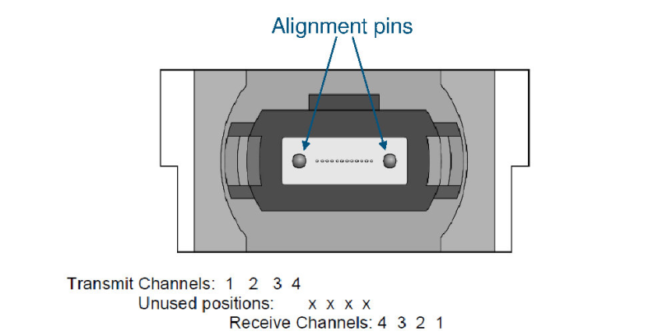

  - Mechanical Dimensions
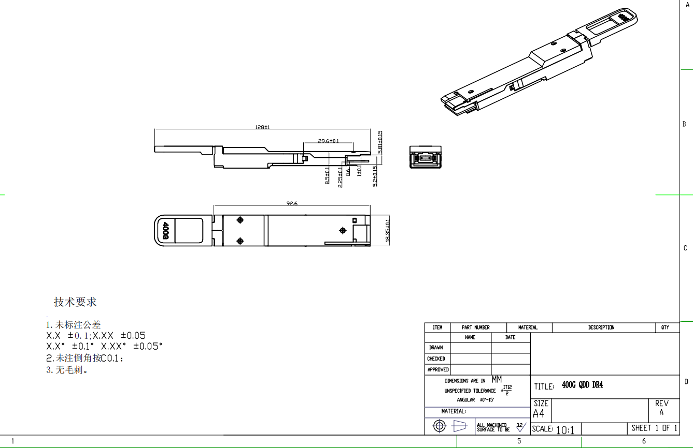

TIBTRONIX reserves the right to make changes to the products or information contained herein without notice. No liability is assumed as a result of their use or application. No rights under any patent accompany the sale of any such products or information.
Published by Shenzhen TIBTRONIX Technology Co., Ltd.
Copyright © TIBTRONIX
All Rights Reserved.

